Linux Permissions and SecurityTheory (1 hour): File and directory permissions in Linux: chmod, chown.Users, groups, and access control.Practical (1 hour): Set up user-specific access to files.Task: Demonstrate restricted access to a directory for specific users.

Tasks

1. Create two new users on your Linux system named 'musicfan' and 'moviebuff', then create a new group called 'playlist' and add both users to this group.

ANS:

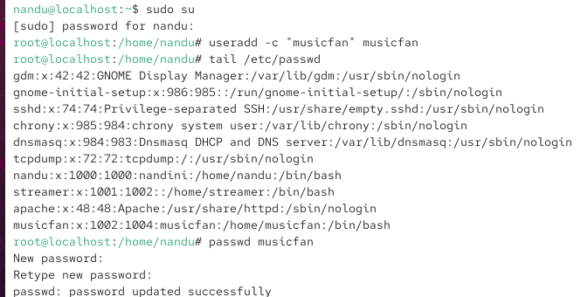

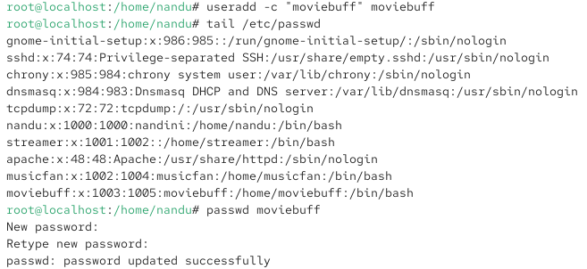

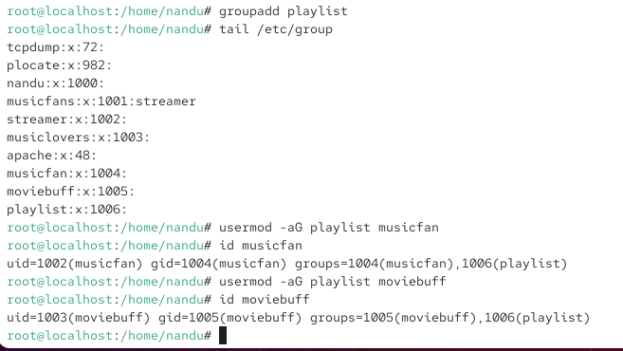

2. Inside your home directory, create a folder called 'spotify_shared'. Set its permissions so only users in the 'playlist' group can read and write files inside it, but others cannot access it. Use chown and chmod with the group ownership and permission bits.

ANS:

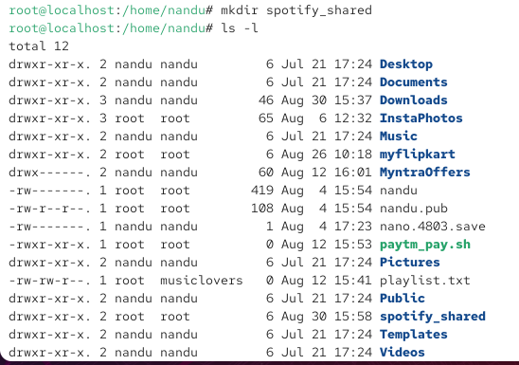

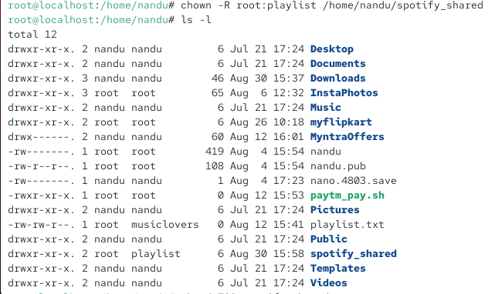

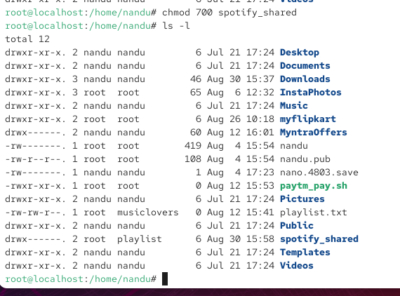

3. Place a text file named 'top_songs.txt' inside 'spotify_shared'. Change its ownership so that 'musicfan' is the owner and 'playlist' is the group, then set permissions so only the owner can edit, group members can read, and others have no access.

ANS:

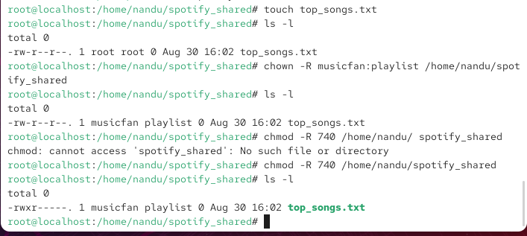

4. Simulate a scenario where 'moviebuff' tries to access 'top_songs.txt'. Switch to the 'moviebuff' user and attempt to open and edit the file. Describe what happens and explain why based on the permissions you set.

ANS:

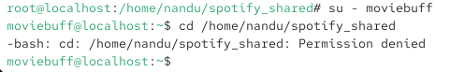

The moviebuff user tried to enter the /home/nandu/spotify_shared directory but received Permission denied.
This means moviebuff does not have the required permission to access the directory and its files.
Therefore, the user cannot open or edit top_songs.txt.

